Experiment 1

Insertion Sort

#include<stdio.h>

#include <time.h>

#include <stdlib.h>

void insertion(int a[], int n)

{

int j;

for(int i =1;i<n;i++)

{

int temp = a[i];

j=i-1;

while(a[j]> temp && j>=0)

{

a[j+1]=a[j];

j--;

}

a[j+1]= temp;

}

}

int main()

{

clock_t t;

int n,a[150000],b;

printf("Enter the size : ");

scanf("%d",&n);

//Average case

for(int i=0;i<n;i++)

{

a[i]=rand();

}

t = clock();

insertion(a, n);

t = clock()-t;

double t1 = ((double)t);

printf("Exution time Average case: %f",t1);

//Best case

for(int i=0;i<n;i++)

{

a[i]=i;

}

t = clock();

insertion(a, n);

t = clock()-t;

double t2 = ((double)t);

printf("\nExution time Best case : %f",t2);

//Worst case

//Best case

int x =n;

for(int i=0;i<n;i++)

{

a[i]=x;

x--;

}

t = clock();

insertion(a, n);

t = clock()-t;

double t3 = ((double)t);

printf("\nExution time Worst case : %f",t3);

}

Output :

For 15000

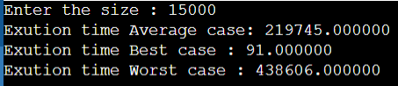

For 35000

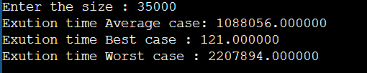

For 55000

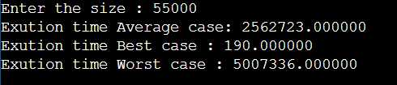

Selection Sort

#include<stdio.h>

#include <time.h>

#include <stdlib.h>

int small(int a[],int p, int n)

{

int small = a[p],pos=p;

for(int i = p+1 ;i<n;i++)

{

if(a[i]<small)

{

small=a[i];

pos=i;

}

}

return pos;

}

void select1(int a[],int n)

{

int pos,temp;

for(int i=0;i<n;i++)

{

pos = small(a,i,n);

temp = a[i];

a[i] = a[pos];

a[pos] = temp;

}

}

int main()

{

clock_t t;

int n,a[150000],b;

printf("Enter size : ");

scanf("%d",&n);

int x =n;

//Average case

for(int i=0;i<n;i++)

{

a[i]=rand();

}

t = clock();

select1(a, n);

t = clock()-t;

double t1 = ((double)t);

printf("Exution time Average case: %f",t1);

//Best case

for(int i=0;i<n;i++)

{

a[i]=i;

}

t = clock();

select1(a, n);

t = clock()-t;

double t2 = ((double)t);

printf("\nExution time Best case : %f",t2);

//Worst case

//Best case

for(int i=0;i<n;i++)

{

a[i]=x;

x--;

}

t = clock();

select1(a, n);

t = clock()-t;

double t3 = ((double)t);

printf("\nExution time Worst case : %f",t3);

}

Output :

For 15000:

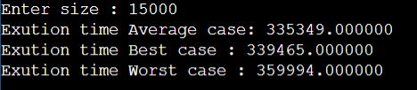

For 35000:

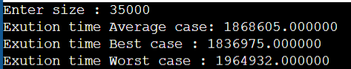

For 55000:

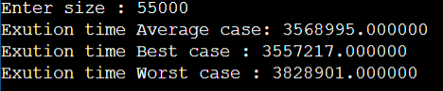

Observation Table :

Table :

|  |  |  |  |  |  |  |  |  |  |  |  |
| --- | --- | --- | --- | --- | --- | --- | --- | --- | --- | --- | --- |
|  |  | | 15000 |  | |  | 35000 |  |  | 10000 |  |
|  | best | average | | | worst | best | average | worst | best | average | worst |
| Insertion sort | 91 | 219745 | | | 438606 | 121 | 1088056 | 2207894 | 190 | 2562723 | 5007336 |
| Selection sort | 339465 |  | | |  |  |  |  |  |  |  |